**TRIBHUVAN UNIVERSITY**

**FACULTY OF HUMANITIES AND SOCIAL SCIENCES**

**LUMBINI ICT CAMPUS**

**Internship Report On**

**“Business Listing Site(Turantcall)”**

A final internship report submitted in partial fulfillment of the requirements for the degree of Bachelor of Computer Application awarded by Tribhuvan University.

**Submitted By:**

Bipin Paudel

T.U. Regd. No: 6-2-1194-68-2019

**Submitted To:**

Lumbini ICT Campus

Department of Computer Application

Gaindakot-4, Nawalpur

March 2024

**LUMBINI ICT CAMPUS**

**SUPERVISOR’S RECOMMENDATION**

I hereby recommend that this internship report prepared under my supervision by **Bipin Paude**l at “**Turantcall a business listing site on own system**” in partial fulfillment of the requirements for the degree of Bachelors in Computer

Application be processed for the evaluation.

----------------------------------

Er. Mod Nath Acharya

Supervisor

Lumbini ICT Campus

Date: March, 2024.

# Acknowledgement

The internship program, a requirement for the completion of my 7th semester of the Bachelor of Computer Application (BCA) degree at Tribhuvan University, has given me the opportunity to acquire technical skills, improve my teamwork and communication skills, and gain insight into the real-world scenario and working environment in the IT industry.

First of all, I would like to express my heartfelt gratitude to my internship mentors, **Mr.Bibek Jaishwal** and **Mr.Suman Suwal** for their invaluable support and assistance throughout my internship. Their patience, motivation, and expertise were instrumental in my success. I am deeply grateful for their guidance and mentorship.

I would like to express my sincere gratitude to the founder **Mr. Sandeep Jaishwal** and management team of **Turantcall**, for affording me the opportunity to work as an intern for the company. Without his support, I would have missed out on this life-changing experience and the chance to expand my knowledge. I am grateful for the technical support and motivation provided by the team at **Turantcall** and appreciate the role Mr. Jaishwal played in making it all possible.

I would like to express my appreciation and thanks to **Tribhuvan University** for providing us with the chance to gain practical experience through an internship and for guiding us in the preparation of this project report. I highly value the university's efforts to instill the necessary skills, abilities, and attitudes in students that will contribute to their future growth. Thank you for this opportunity.

I also want to thank my co-workers and the web development team for all of their support, encouragement, and useful criticism they gave me throughout the internship.

Thanking,

Bipin Paudel

T.U. Exam Roll No 6-2-1194-68-2019

# Abstract

This internship report documents the work completed during my internship at Turantcall Pvt Ltd, where I served as a Laravel developer intern on the company own project Turantcall. This report was prepared as part of the requirements for the Bachelor of Computer Application at Tribhuvan University. The objectives of this internship are to apply my practical and theoretical knowledge of software development to solve real-world problems, understand how software development is carried out in an actual company, and learn to work as a Laravel developer in a team environment.

In this report, you will find a detailed description of the Turantcall project, including a systematic overview of the work completed during the software development process. All aspects of the project, including the development process, implementation, and usage of the platform, are discussed in depth.

The main purpose of this internship was to gain practical experience and apply the knowledge and skills learned during my academic studies to real-world problems in a professional setting. In this report, I provide a detailed analysis of the development process, implementation, and usage of the Turantcall project from the perspective of a software developer.

This report includes an introduction and objectives of the project, information on the organization, and a summary of the activities and tasks completed during my internship. The conclusion and learning outcomes section includes a discussion of the processes, practices, and procedures that I encountered and learned during my internship at Turantcall.

Additionally, this report includes my observations on employee satisfaction, motivation levels, and the working environment at Turantcall. Overall, this internship provided a valuable opportunity to gain practical experience and apply my knowledge and skills in a professional setting.

# TABLE OF Contents

**Acknowledgement ii**

**Abstract iii**

**CHAPTER 1: INTRODUCTION 1**

**1.1. Introduction 1**

**1.2. Problem Statement 1**

**1.3. Objectives 2**

**1.4. Scope and Limitation 2**

**1.5. Report Organization 3**

**Chapter 2: Introduction to Organization 4**

**2.1. Organization Details 4**

**2.2. Organizational Hierarchy 4**

**2.3. Working Domains of Organization 4**

**2.4. Description of Intern Department 5**

**CHAPTER 3: BACKGROUND STUDY AND LITERATURE REVIEW 6**

**3.1. Background Study 6**

**3.2. Literature Review 6**

**Chapter 4: Internship Activities 7**

**4.1. Roles and Responsibilities 7**

**4.2. Weekly Log 7**

**4.3. Description of the Project Involved During Internship 10**

**Chapter 5: Conclusion and Learning Outcomes 12**

**5.1. Conclusion 12**

**5.2. Learning Outcomes 12**

References 13

Appendix - Screenshots 14

**List of Figures**

**Figure 1: Organization Hierarchy** 4

**Figure 2: Landing Page** 14

**Figure 3: Login Page** 15

**Figure 4: Listings Page** 16

**Figure 5: Listing Detail Page** 17

**Figure 6: User Dashboard** 18

**Figure 7: Adding Business Information Form** 18

**Figure 8: Pages Table** 19

**Figure 9: Add New Page** 19

**Figure 10: Manage Meta Tags Page** 20

**Figure 11: Manage Listing Type Page** 20

**Figure 12: Manage Sub Stream Page** 21

**List of Tables**

**Table 1: Weekly Log Sheet** 7

# Chapter 1: Introduction

* 1. **Introduction**

A Business Listing Site is like an online directory where you can find information about different businesses. It's a place where business owners can list their services, making it easier for potential customers to find them online. These sites help businesses increase their visibility on the internet and provide users with quick and concise information about each business.

Business Listing Sites are becoming more popular because they help businesses advertise their services and attract potential customers. Turantcall is an example of a Business Listing Site that offers comprehensive business information in a user-friendly format. It's designed to make it easy for users to find the information they need about different businesses quickly and efficiently.

They offer various features like SMS notifications, business ratings and reviews, inquiry forms, and other tools to make the listing process easier. Turantcall even provide support services to help businesses with technical issues or listing assistance.

* 1. **Problem Statement**

Turantcall aims to address the challenge faced by local businesses in establishing an online presence. In the past, businesses relied on traditional methods like phonebooks to reach customers. However, with the advent of the internet, the need for a strong online presence has become essential. Many local businesses struggle to showcase their services effectively online, hindering their ability to attract customers in today's digital age.

Turantcall steps in to bridge this gap by providing a platform where local businesses can easily list their services online. Similar to how phonebooks used to compile business information in one place, Turantcall acts as a modern-day directory, allowing businesses to reach a wider audience. By offering a user-friendly interface and comprehensive business listings, Turantcall empowers local businesses to enhance their online visibility and connect with potential customers more efficiently.

* 1. **Objectives**

Turantcall aims to address these above-mentioned issues by providing a platform for local business to digitize their online presence to connect with different customers and help them in long term. By addressing these challenges, Turantcall aims to make easier for individuals to enter the Turantcall ecosystem. For buildup online presence, promote local businesses and help to connect business owners and customers in long term.

Some main Objectives of Turantcall are as follows:

* To provide a better platform for local business to list their business in internet in affordable way.
* To promote the local business and connect with their targeted customers.
* To provide a one-stop information portal for people to have a near by business information.
* To enhance the quality and presentation of database to deliver a more user-friendly experience for customers.
  1. **Scope and Limitation**

**Scope**

Turantcall is a special website where businesses can put their information online to reach more customers. It offers different packages to help businesses promote themselves on the internet and find new customers.

* Turantcall provides a platform for businesses to list their services online, increasing their visibility to potential customers.
* It offers various packages tailored to businesses' needs, allowing them to choose the best option for promoting their services online.
* Businesses can register for free on Turantcall's user module, making it accessible to businesses of all sizes.
* Turantcall allows local businesses to create microsites to showcase their services, enhancing their professional image and attracting more customers.
* In addition to basic listings, Turantcall offers features such as SMS notifications, customer reviews, and inquiry forms to further boost businesses' online presence.
* Turantcall may provide support services to assist businesses with technical issues or optimizing their listings for better visibility.
* The platform aims to help businesses reach a wider audience and generate more leads, ultimately increasing their success in the online marketplace.

**Limitation**

Some Limitation of Turantcall are as follows:

* It is solely an online platform for promoting businesses, limiting its reach to internet users.
* In the free listing option, businesses may end up being listed towards the bottom of the page, potentially reducing visibility compared to premium listings.

## **Report Organization**

There are five chapters in this report, each of which is discussed below:

* **Chapter 1** provides an overview of the system, including its purpose and functions. It also includes the problem statement, outlining the issues the system aims to address. This chapter also includes details on the objectives of the project, as well as its scope and limitations.
* **Chapter 2** covers information about the organization, including its hierarchy and the departments within it. It also discusses the specific unit or department where the internship took place.
* **Chapter 3** presents a review of related literature and background information on the topic.
* **Chapter 4** discusses the roles and responsibilities of the participants, as well as a weekly log of their activities and tasks during the internship. It also includes a description of the project and the specific tasks and activities completed as part of the internship.
* **Chapter 5** concludes the report with a summary of the key learning outcomes and findings from the internship experience.

**Chapter 2: Introduction to Organization**

* 1. **Organization Details**

TurantCall Pvt Ltd is an innovative company established in 2073 B.S by a group of enthusiastic individuals to make all kinds of information available online. Turantcall, Nepal local search engine, provides Best Deals, Restaurant, Ticket Booking , Hotels Booking , movies, Hospital and Repair. In the world of fast growing technology time has been a great matter of concern. People want to get services which are within the reach of a click as it is time saving and easy to compare products and services online. Turant call has made an endeavor to bring all such information at a common point and make life technologically sound. We act as a bridge between the buyer and seller and help them to exchange numbers, chat online so that they can buy or sell the products or services.

## **Organizational Hierarchy**

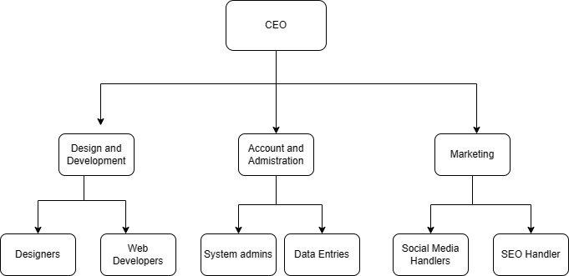

**Figure 1: Organization Hierarchy**

## **Working Domains of Organization**

**Search Engine Optimization (SEO):**

Optimizing the portal site to rank well on search engines, thereby increasing visibility and attracting more users searching for businesses in specific locations or industries.

**Data Collection and Compilation:**

Gathering information about businesses, including their contact details, services offered, operating hours, and other relevant information.

**Database Management:**

Organizing and maintaining a database of businesses and their information in a structured and easily accessible format.

**Marketing and Promotion:**

Promoting the portal site through various channels to attract businesses to list their services and to increase user traffic.

**Customer Support:**

Providing assistance to users and businesses regarding inquiries, technical issues, and general support related to the portal site.

**Monetization Strategies:**

Implementing strategies to generate revenue, such as through advertising, premium listing options for businesses, or subscription services for additional features.

**Analytics and Reporting**

Monitoring website traffic, user behavior, and engagement metrics to gain insights into the performance of the portal site and identify areas for improvement.

## **Description of Intern Department**

Turantcall offers internships for budding professionals to gain hands-on experience. To apply, candidates submit an online application and their qualifications are reviewed. Those fitting the company's needs are interviewed via Google Meet. Once accepted, interns receive the same support and facilities as full-time staff.

During my time at Turantcall, I collaborated with skilled software developers, treated equally and given access to necessary resources and training. The company follows a 6-day workweek from 10 AM to 5:00 PM. Turantcall prioritizes interns' growth in a supportive and inclusive atmosphere.

# Chapter 3: Background Study and Literature Review

* 1. **Background Study**

Business listing information portals are websites where you can find details about different businesses, like their phone numbers, addresses, and what they offer. They've come a long way from the old phone books to now being online. These sites are really important because they help businesses get noticed and trusted by people looking for services. For example, if you want to find a nearby restaurant, you can just search on one of these sites and read reviews from other people who have been there. It's like having a big directory in your pocket! These sites also make it easy for businesses to talk to their customers and even advertise to them. And since most people use their phones for everything, these sites are made to work well on mobile devices too. Overall, they're super helpful for both businesses and customers, making it easier to connect and find what you need. (Vital)

One popular business listing information portal is Turantcall, which helps businesses get noticed online by providing excellent services. Many businesses have started using Turantcall and have received potential customer leads through it. Overall, the use of business listing sites has revolutionized internet advertising, reaching a wider audience more effectively.

* 1. **Literature Review**

Business listing websites are super important for businesses because they help them get noticed by people looking for services. These websites make it easy for businesses to show what they offer and for customers to find them. By being on these sites, businesses can reach more people and build trust with potential customers. Plus, these sites also make it easier for businesses to talk to their customers and even advertise to them. (Park, 2004)

For people looking for services, business listing sites are like a big directory where they can find all the information they need. They can easily see details about different businesses, read reviews from other people, and make informed decisions about where to go. These sites also let them connect with businesses directly, making it convenient for everyone. Overall, business listing portals help businesses get noticed and make it simple for people to find what they're looking for. (Strum, 2005)

**Chapter 4: Internship Activities**

* 1. **Roles and Responsibilities**

During the internship period at Turantcall, I have had the role of a web developer focused on backend development using PHP and the Laravel framework. In addition to my primary responsibilities, I have also had the opportunity to work with Deployment on servers, setting up github with server. My responsibilities have included:

* Working with my mentor and team to improve my skills as a web developer.
* Completing tasks and projects assigned by my mentor in a timely manner.
* Learning about current web development trends and technologies.
* Developing essential work skills such as effective communication, teamwork, and coordination.
  1. **Weekly Log**

**Table 1: Weekly Log Sheet**

|  |  |  |
| --- | --- | --- |
| **PROJECT: TURANTCALL**  Name: Bipin Paudel | | |
| **Weeks** | **Task Done** | **Mentor’s Comment** |
| **Week 1** | * Introduction of Company * Identified various issues on the website. * Listed down tasks for fixing issues. | * Gave a Positive feedback |
| **Week 2** | * Fixed CV download issue. * Wrote a blog on the importance of business listings and online presence. | * Appreciate me for fixing the cv issue. * Gave a suggestion to improve blog. |
| **Week 3** | * Edited documentation page according to given dates and package information. * Worked on CRUD operations for documentation. | * Saw my tasks and said carry on work. |
| **Week 4** | * Fixed admin change password issue and form changes for user pages. * Started working on editing news pages. | * Saw my tasks and said carry on work. |
| **Week 5** | * Edited news pages in the user panel and attempted to create backups and zip files unsuccessfully. | * See the tasks and allocate task to backup files. * Said to Contact Hosting Provider for help. |
| **Week 6** | * Continued working on homepage and sidebar fixes, as well as managing ads in the admin panel. | * Saw my tasks and said carry on work. |
| **Week 7** | * Ensured code correctness and discussed furniture details for a new project in a Google Meet. | * Explained about new project . |
| **Week 8** | * Set up CPanel connection with GitHub and worked on website content updates. | * Saw my tasks and said carry on work. |
| **Week 9** | * Uploaded slider images, updated About Us and Gallery sections, and worked on Contact Us messages. | * Gave a positive feedback on this and said to back on do turantcall project. |
| **Week 10** | * Handled server errors, frontend issues, and integrated new features into the website. * Collaborated with a new senior member and discussed Turantcall. | * Senior sir discussed about the project and allocate tasks for me. |
| **Week 11** | * Rectified site errors, created a testing domain, and deployed the testing project. * Removed unnecessary JavaScript libraries. | * Gave positive comments on testing sites. |
| **Week 12** | * Updated category images and worked on SEO for the testing site. * Implemented changes in listing and category tables in the admin module and user module. | * Gave feedback to improve in SEO. |
| **Week 13** | * Conducted testing on the testing site and merged changes into the master branch on GitHub. * Reported errors to senior staff and made adjustments to static and dynamic routes. | * Gave a suggestion on writing main table code and gave some useful coding tips. |
| **Week 14** | * Conducted testing on the testing site and merged changes into the master branch on GitHub. * Reported errors to senior staff and made adjustments to static and dynamic routes | * Saw my tasks and said carry on work. |
| **Week 15** | * Investigated and resolved database issues. * Conducted testing on the testing site. * Added lazy loading attribute to image tags and worked on featured listings in the admin panel. | * Saw tasks and gave a positive feedback. |
| **Week 16** | * Enhanced SEO by working on meta titles and descriptions. * Reported errors and worked on OG tags for SEO improvement. * Fixed site errors and worked on middle ads for search listings. | * Saw my tasks and gave suggestions to improve seo. |
| **Week 17** | * Continued reporting errors and made adjustments to listing types and values. * Added cities filter to the listings page and worked on listing page logic. * Addressed site errors and refined listing page logic. | * Saw my tasks and said carry on work. |
| **Week 18** | * Conducted testing on the testing site. * Continued testing and ensured website functionality. | * Saw my tasks , guided me on about education listing types and value. |

* 1. **Description of the Project Involved During Internship**

Turantcall is a business listing site designed for business owners to register their businesses online. It offers a user module with a dashboard where users can manage their business information and create and update their listings. The site provides three subscription packages, each offering different services based on the package chosen.

For system administrators, there's a separate admin portal where they can handle various activities on the site. Each listing requires admin approval before being registered on the site. Admins also have the capability to create sub-admins and define their roles and permissions. They have major access to the system, overseeing its operations.

On the main site, listings are categorized by categories and sub-categories for easy navigation. Each listing detail page provides comprehensive information about the business, including user pages (such as 'about us' and 'services'), contact information, reviews and ratings, galleries, and links to the business's social media profiles and videos.

The project is built on the Laravel Framework, utilizing Livewire, which is a Laravel package enabling the creation of powerful and interactive web applications using PHP and Blade. My primary tasks involved resolving site issues and enhancing the educational categories section tailored for schools and colleges. I contributed by implementing new page management functionalities and adding features for listing types and values.

During the internship period, following technologies were learned and used:

**Backend Programming Languages:** PHP

**Web Frameworks:** Laravel Framework,Livewire

**Frontend Technologies:** HTML, CSS, JavaScript

**Frontend Frameworks:** Bootstrap, jQuery, AJAX

**Database and Storage:** MySQL and MariaDB,Laragon

**Developer Tools:** Visual Studio Code.

**Web Server:** Cpanel of Himalayan Hosting

**Collaboration Tools:** Git and Github

Overall, Turantcall aims to provide a number one business listing platform for local business in Nepal.

**Chapter 5: Conclusion and Learning Outcomes**

* 1. **Conclusion**

I was given the opportunity to work on a variety of projects and tasks, which allowed me to gain practical skills and knowledge in web development, particularly in the areas of backend development with PHP and Laravel. I also had the chance to work with a talented and supportive team, who provided guidance and mentorship throughout the internship period.

Overall, this internship has been a great opportunity for me to apply my theoretical knowledge in a real-world setting and to learn from professionals in the field. I am grateful for the support and guidance provided by my mentor, Mr.Suman Suwal, and the entire team at Turantcall. I believe that the skills and experience gained during this internship will be beneficial in my future endeavors and career development.

* 1. **Learning Outcomes**

Following are the learning outcome of this internship period:

* Learned about professional work ethics and responsibilities in an organization.
* Improved communication and teamwork skills.
* Learned to write clean, maintainable, and efficient code.
* Learnt about how to deploy the laravel project on server.
* Learned how to Establish connection between github and web-server and go on agile process.
* Debugging and troubleshooting issues in the code.
* Collaborating with team members using git and learned about project management tools which helped during internship period.

# References

Park, C.-S. (2004). A study on the Web portal industry. *Retrieved June*, 2000.

Strum, S. L. (2005). *A cognitive study of the use of the Internet by minority small business owners for information research and the design and development of a small business information portal.* Nova Southeastern University.

Vital, C. (n.d.). BUSINESS LISTING DIRECTORY. *vitalbusiness*.

(Strum, 2005)

# Appendix - Screenshots

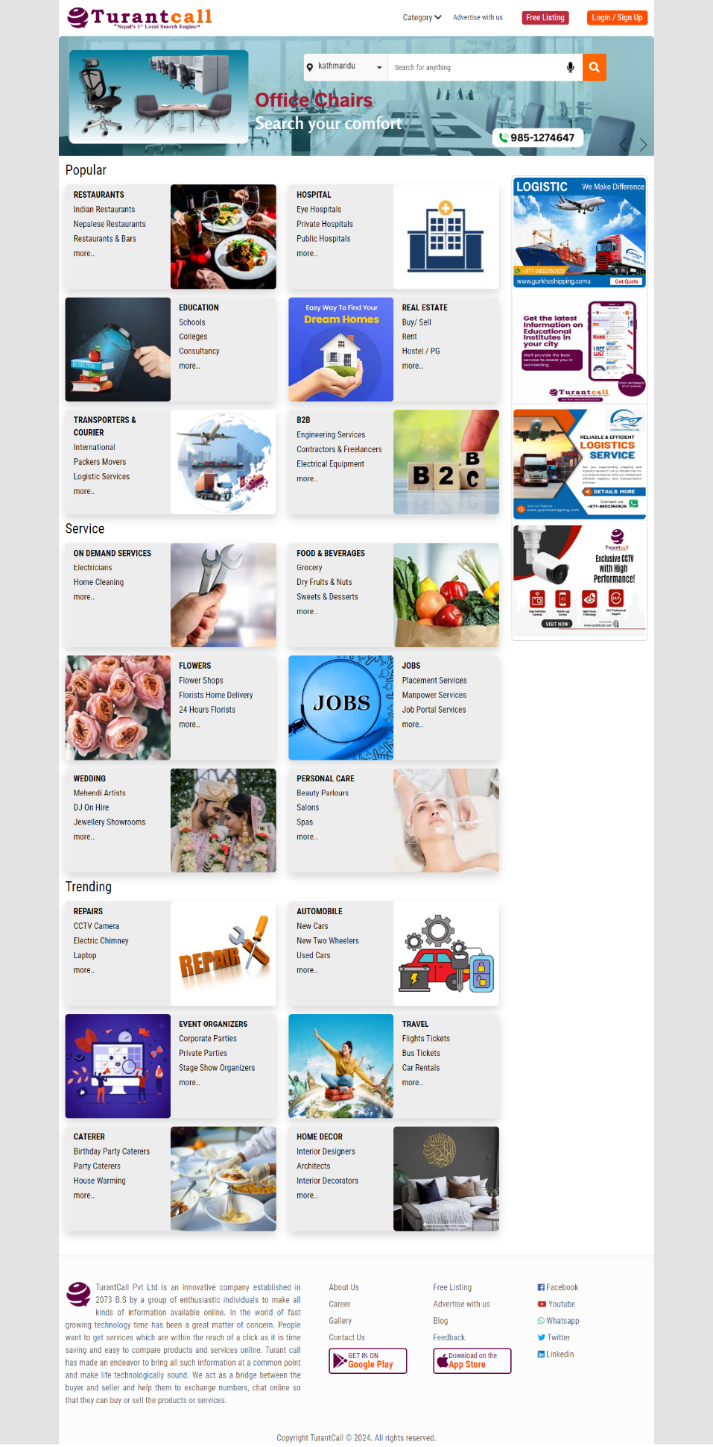

Figure 2: Landing Page

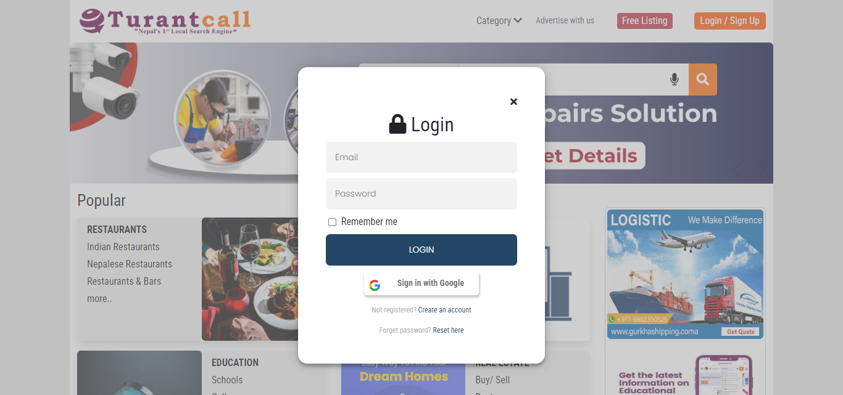

**Figure 3: Login Page**

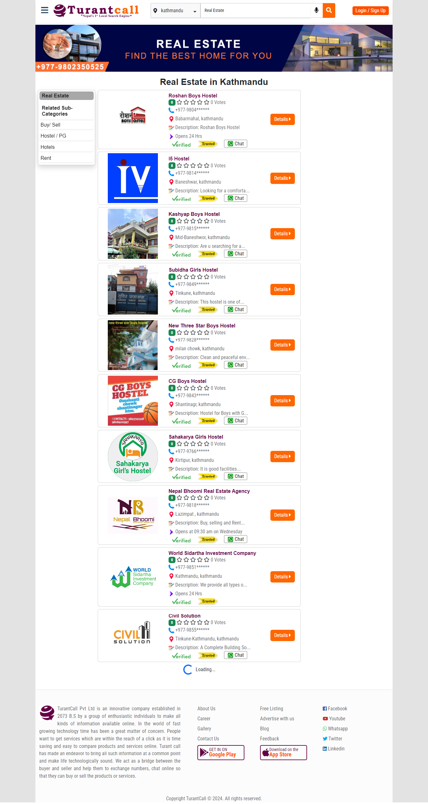

**Figure 4: Listings Page**

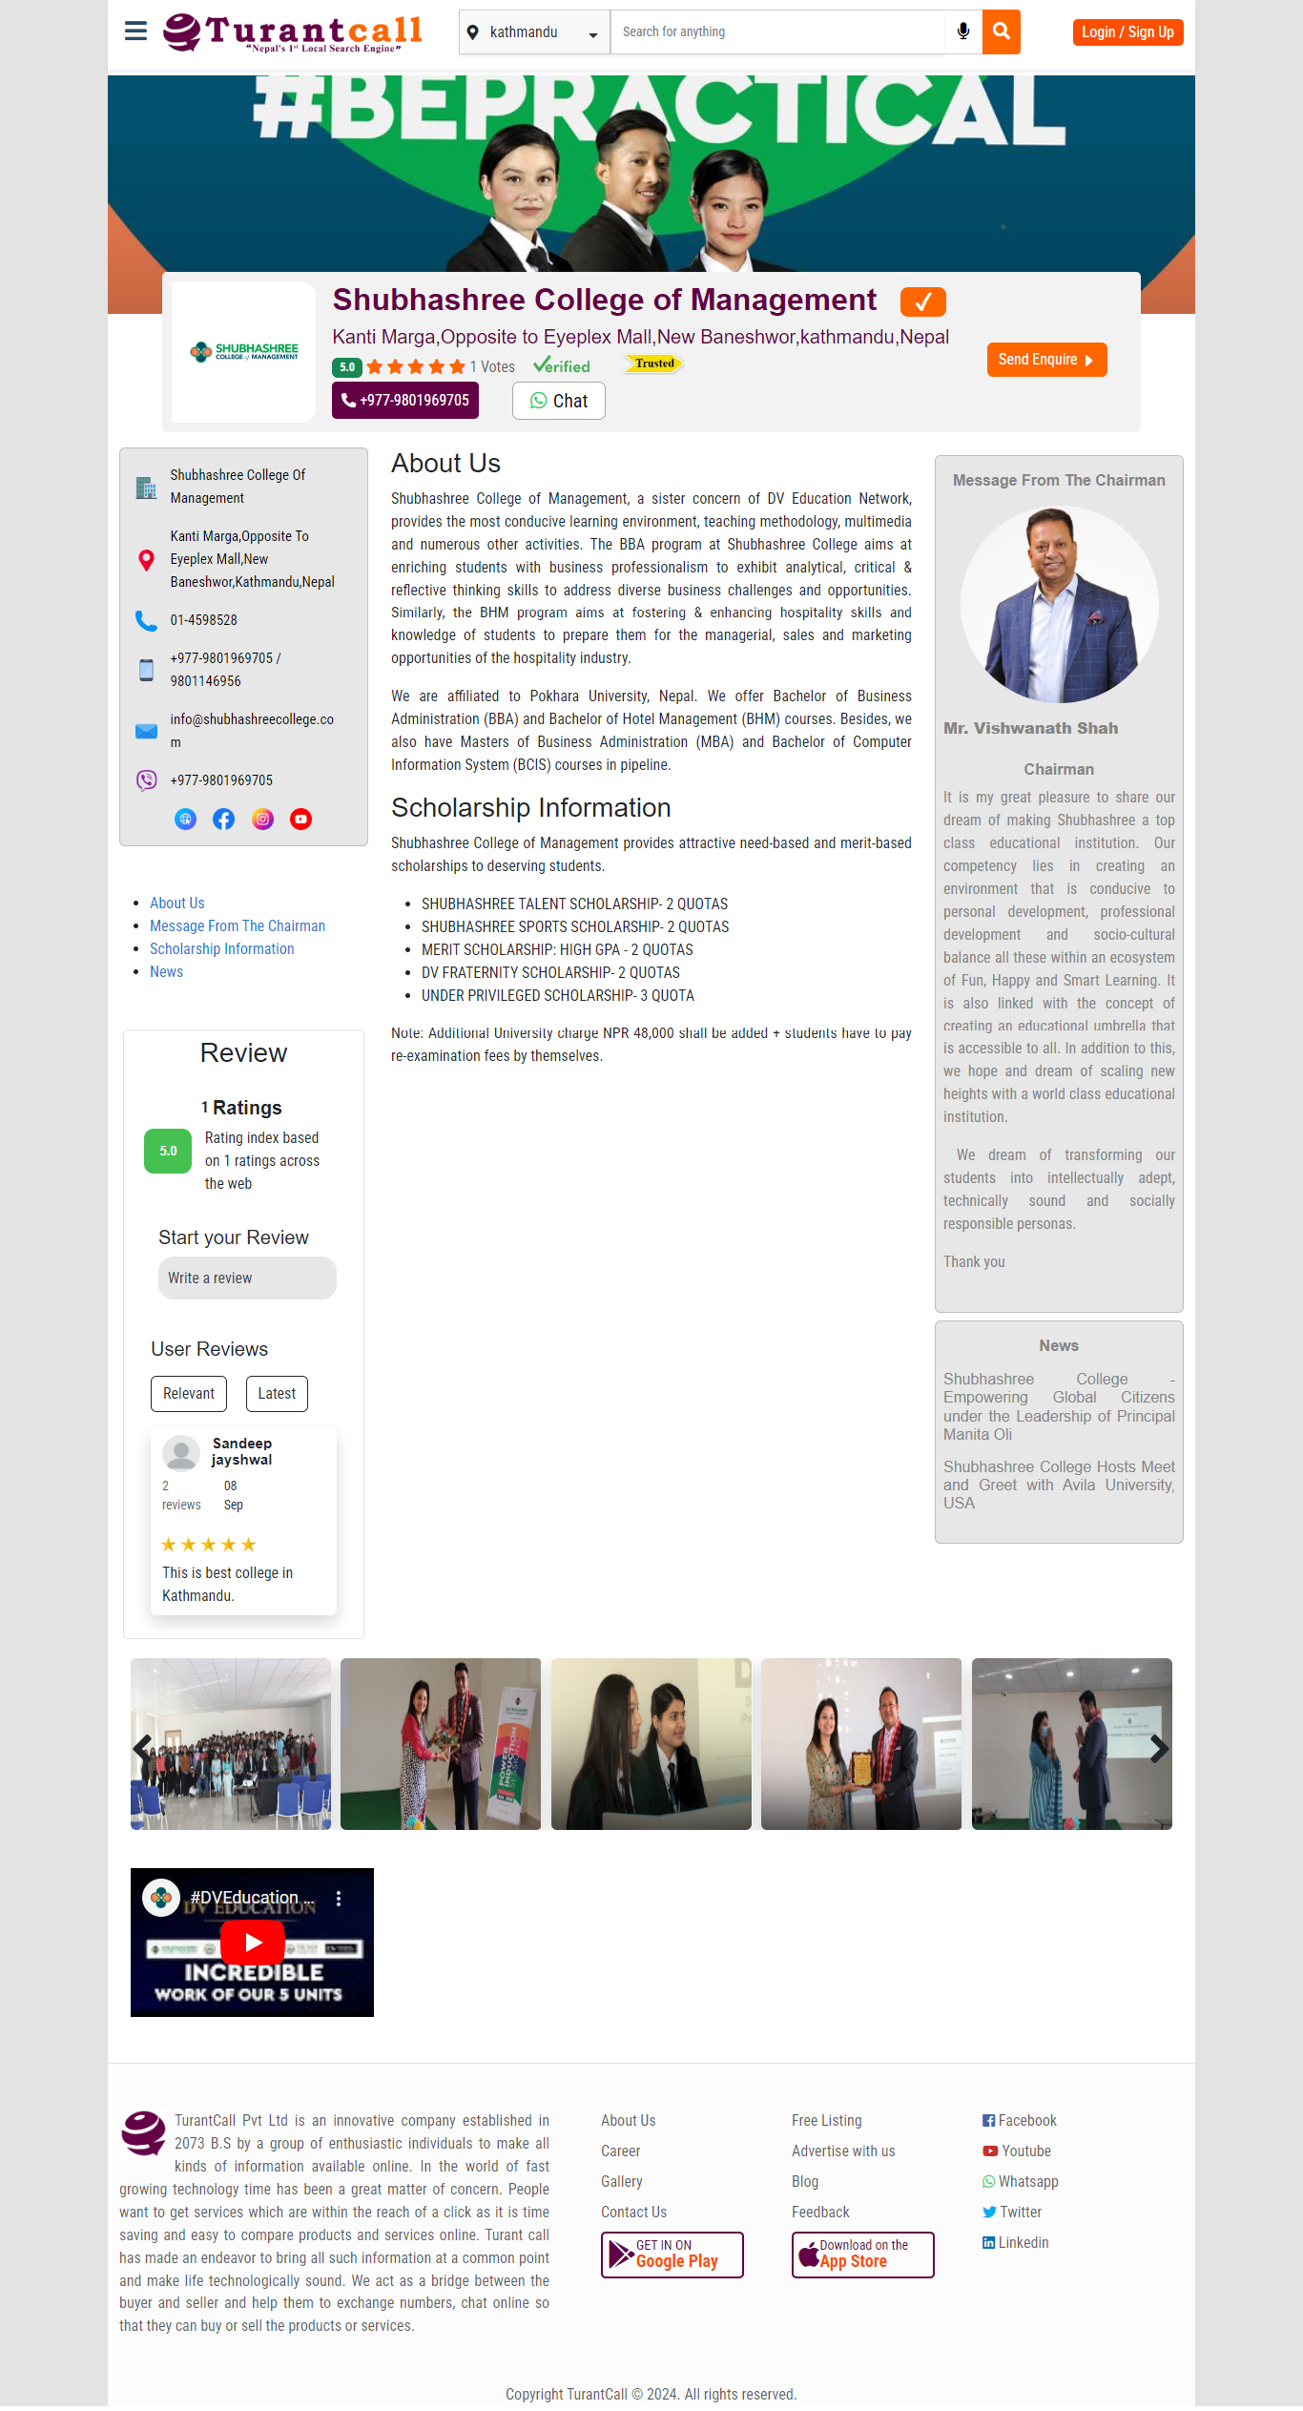

**Figure 5: Listing Detail Page**

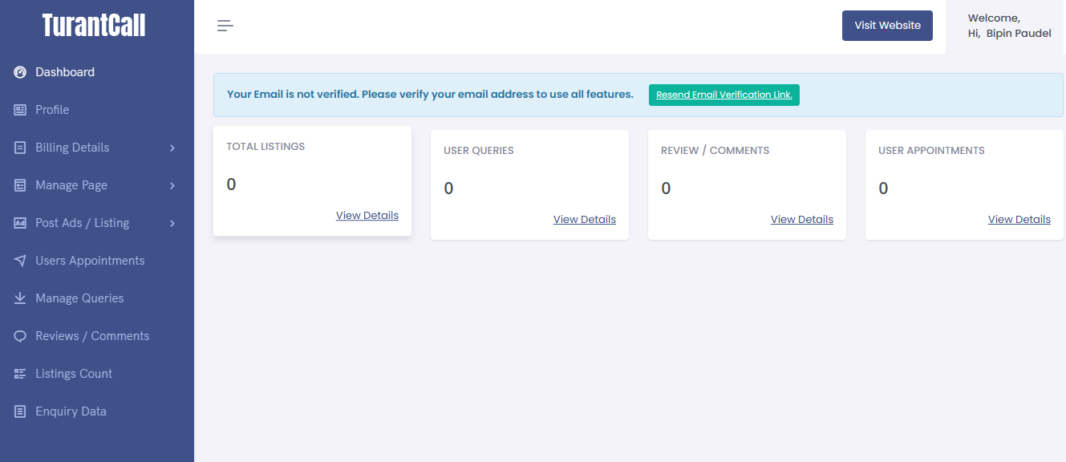

**Figure 6: User Dashboard**

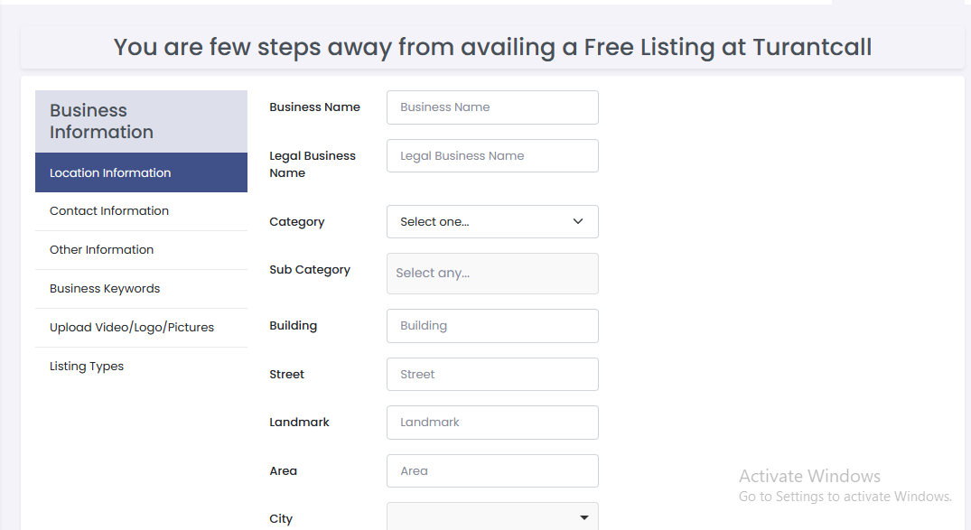

**Figure 7: Adding Business Information Form**

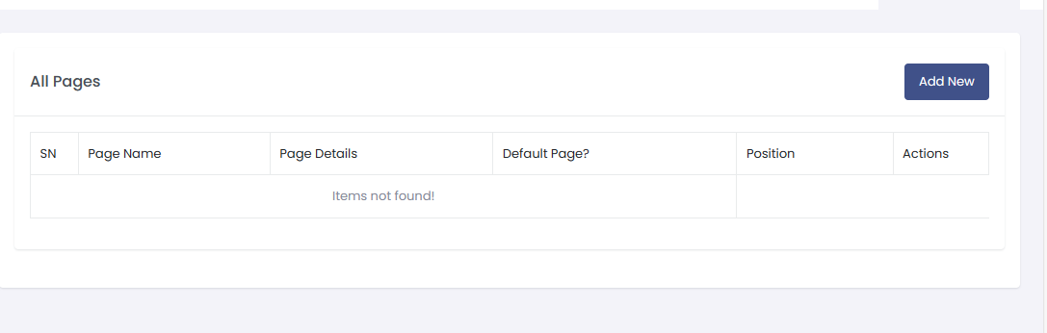

**Figure 8: Pages Table**

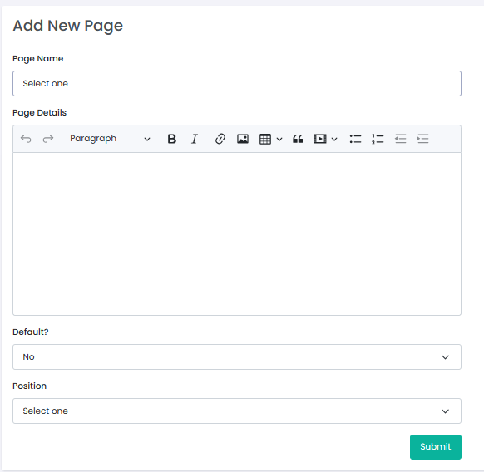

**Figure 9: Add New Page**

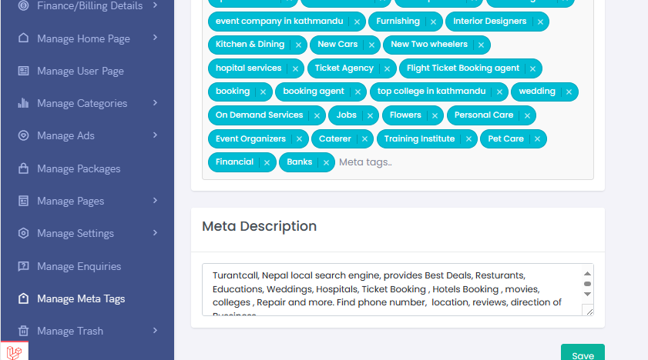

**Figure 10: Manage Meta Tags Page**

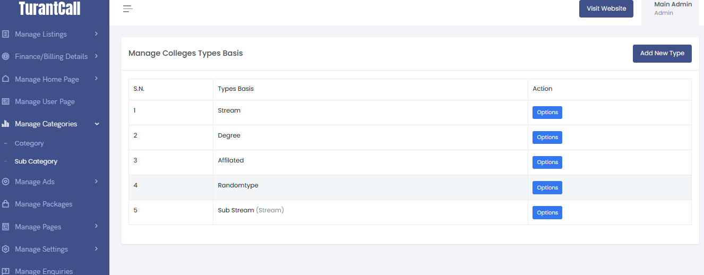

**Figure 11: Manage Listing Type Page**

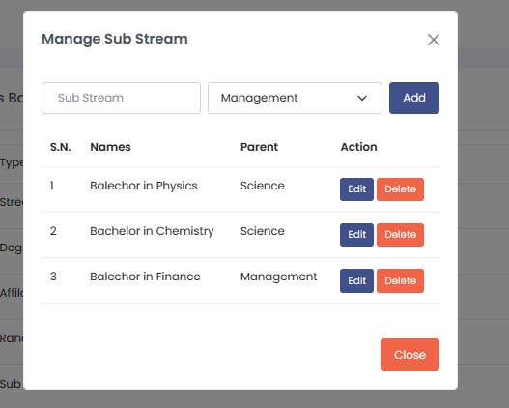

**Figure 12: Manage Sub Stream Page**